Final Project Introduction to Computer Graphic

Rover Vos 12235834

30/06/2023

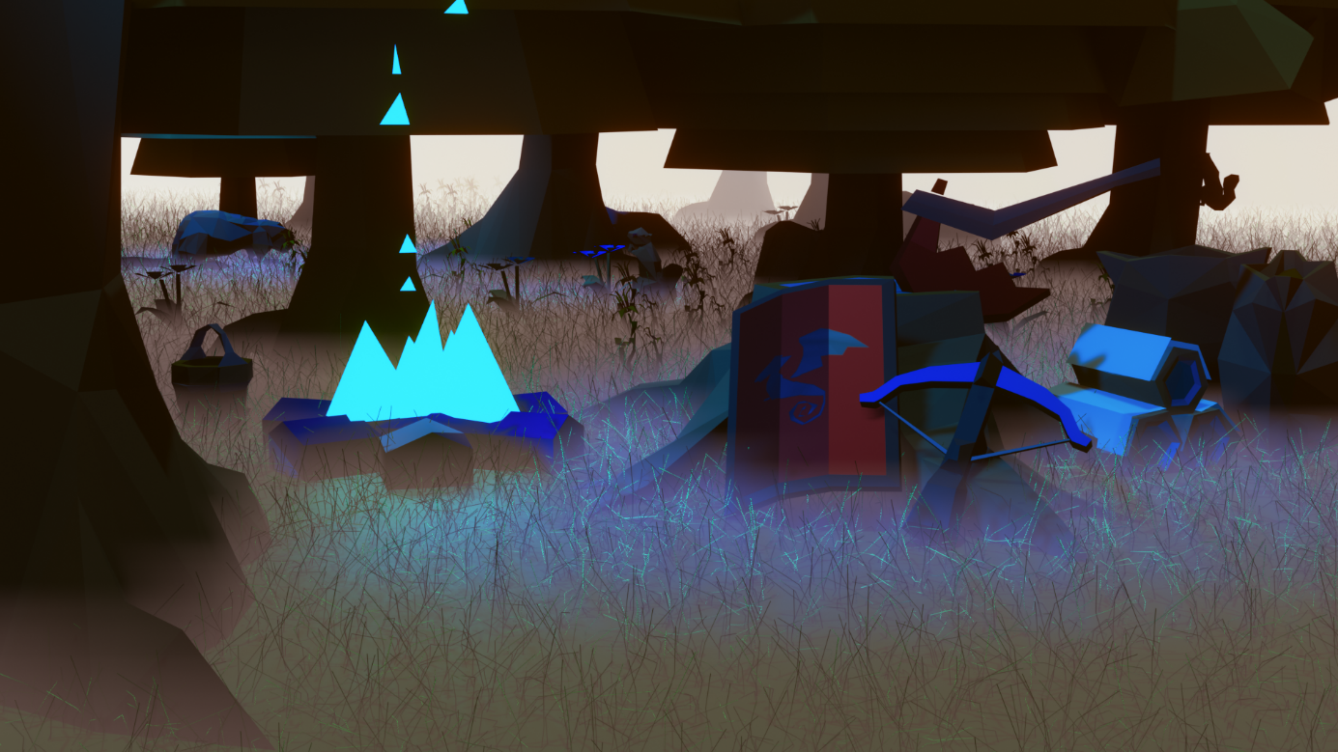

**Introduction**

For the final project I created a custom scene using 3 self-made objects and many different objects that I imported from *OldSchool RuneScape*(JAGEX, 2013). I’m in luck that *OldSchool RuneScape* has a very low poly art style. Furthermore I decided to not use any tutorials to see how far I could get without the internet. This proofed a nice challenge to my blender knowledge.

To create my scene I first replicated 3 items from *OldSchool RuneScape*, a Dragon sq shield, a Rune crossbow and a Dragon axe(Figure 1). These are one of my personal favourite items. To replicate these I made multiple pictures of the items in the game to use as a reference image. Then I worked my way with the extrude tool and some other tools to create the items. Made some simple custom shaders for them and overlayed an image on the shield shader.

To fill up the scene I exported many different objects from *OldSchool RuneScape* with the *RuneLite Model Exporter* Plugin. This was a great way to fill up the scene with life in a fast manner.

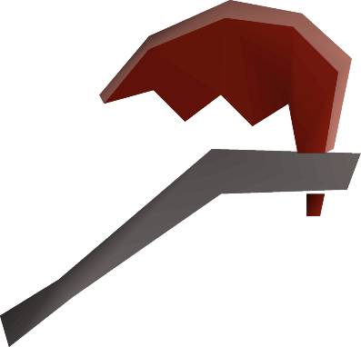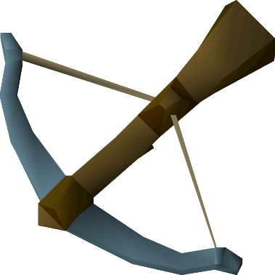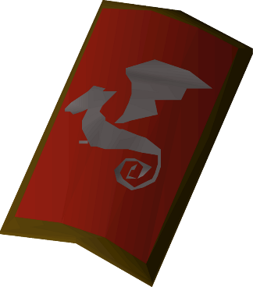

Figure Object I created. Images taken from https://oldschool.runescape.wiki/

**What went wrong**

To be honest, it was a rather simple adventure. I had no problems modelling any of the 3D models and the setting up of the scene was quite fast. But a couple of points I found annoying.

My biggest gribe was that a specific java program that allows me to import *OldSchool RuneScape* models with a rig and animations didn’t work.

I’m not really happy about is the lighting, I wanted a bit more of a moon beam effect, which I didn’t manage to do.

I think I missed the vibe I went for initially A little bit. I wanted to created a cozy lumberjack after work place vibe, but it became a rather gloomy and mysterious scenario instead. I would say that is because of the mist.

I had a bit of problems with the grass, if you look really closely you will see some grass poking out of the fire and through the shield.

**What went well**

A lot of things went well. I had great success with my image references for the 3D models and I could create the models rather fast and the importing of the models war super easy.

Even do I didn’t get my moon beams, I quite like the effect the light has on the beaver.

I’m happy with how I managed to create a mist backdrop, as at first I only had a black background which looked really weird. Now it looks like a very mysteries world.

I really enjoyed the placing of all the object. It quite funny to see how hard it is to place an object realistically and how you want it, but in the end I figured out that it doesn’t need to be real, it just needs to look real to the camera. This was a very nice realisation and helped me create a better scene. For example the shield is floating in front of the tree stump, not laying against it.

**Blender tools used**

I used a particle System with the hair modifier on a plain to create grass.

The basic models I created with basic 3D model tools like extrude, Boolean modifier, Loop cut, inset face, etc.

I used the composer to change some of the saturation in the scene.

I used a depth volume material to create mist, the ground and back mist are the same.

For the 3D models I made custom shaders to give them some colour and used an image shader to place the dragon on the shield.

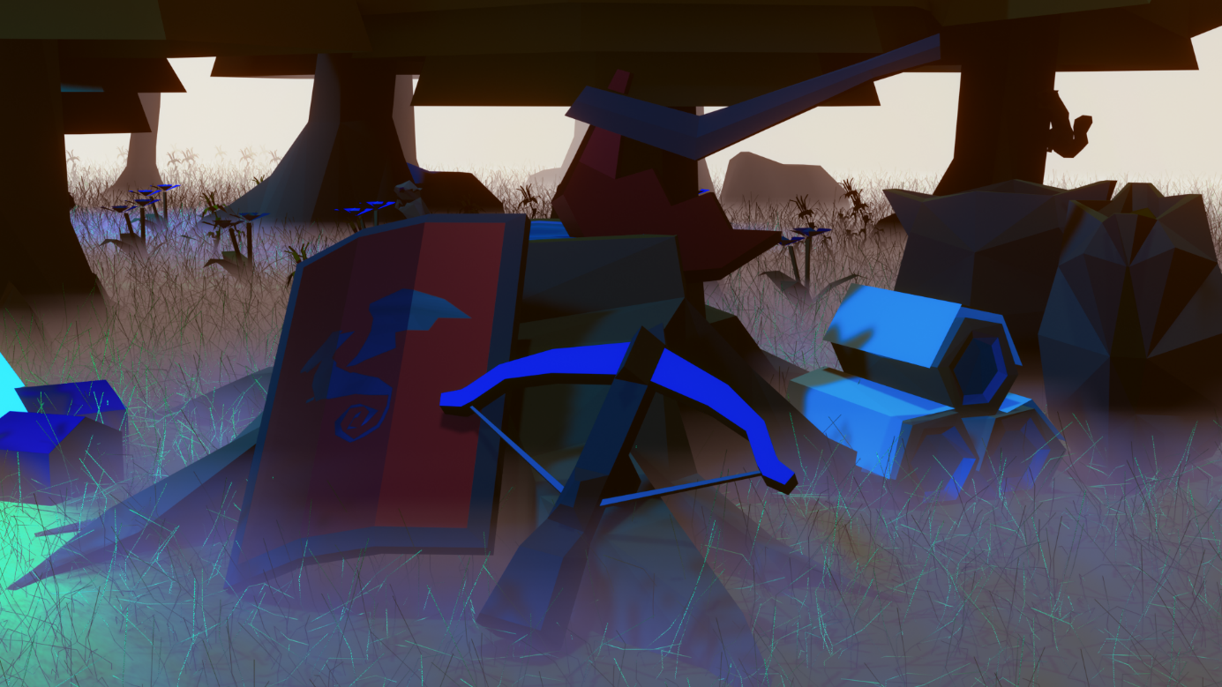

Figure A close up of the 3 objects I made

Bibliography

JAGEX. 2013. *OldSchool RuneScape.* UK: JAGEX.

Open Source GitHub. *RuneLite.* 2016. V1.10.6.1. GitHub. Windows/Mac/Unix. 2016.